**MYD-JA5D4X**

**Product User Manual**

Version 1.0

May.28.2015

**Revision History**

|  |  |  |
| --- | --- | --- |
| **Version Number** | **Instruction** | **Date** |
| V1.0 | Initial Version | 2015.05.28 |

# Contents

Contents 1

Chapter 1 Product Overview 2

1.1 Product Introduction 2

1.2 Product Overview 2

Chapter 2 Hardware Resource Introduction 3

2.1 Core Board Resources Overview 3

2.2 Bottom Hardware Resources 3

Chapter 3 Hardware Guide 5

3.1 Plate Interface Specification 5

3.1.1 MYD-JA5D4X I/O Interface 5

3.2 Function Module Description 7

3.2.1 Ethernet 7

3.2.2 LCD Touch Screen 8

3.2.3 HDMI Interface 9

3.2.4 Audio CODEC 10

3.2.5 USB Interface 10

3.2.6 USART Interface 10

3.2.7 ISI Interface 11

3.2.8 TF Card 11

3.2.9 JTAG Interface 12

3.2.10 Extended Interface 12

Chapter 4 Software Resources Instruction 15

4.1 Linux Software Resources 15

Chapter 5 Software Guide 17

5.1 Download Firmware to Development Board 17

5.2 Start Development Board 17

Chapter 6 Machine Parameter 18

Appendix 1 Warranty & Technical Support Services 20

# Product Overview

## Product Introduction

MYD-JA5D4X is composed by core board named MYC-JA5D4X and base board named MYB-JA5D4X. The core of MYC-JA5D4X is the Atmel® | SMART SAMA5D4 Series is a high-performance, power-efficient ARM® Cortex®-A5 processor MPU capable of running up to 528 MHz.It integrates 512MB DDR2 SDRAM, 512MB Nand Flash or4GB eMMC,4MB Data Flash,64KB EEPROM. MYD-JA5D4X development board supports Linux 3.18, providing relevant source code, and has rich peripherals including high-speed USB, Audio input and output, SPI, IIC, LCD interfaces, RS485, JTAG debug interface, Serial port, Touch Screen, ISI interface, HDMI Interface and TF card interface, etc. These constitute an integrated software development environment, and can help reduce products developing cycle and make launching fast.

## Product Overview

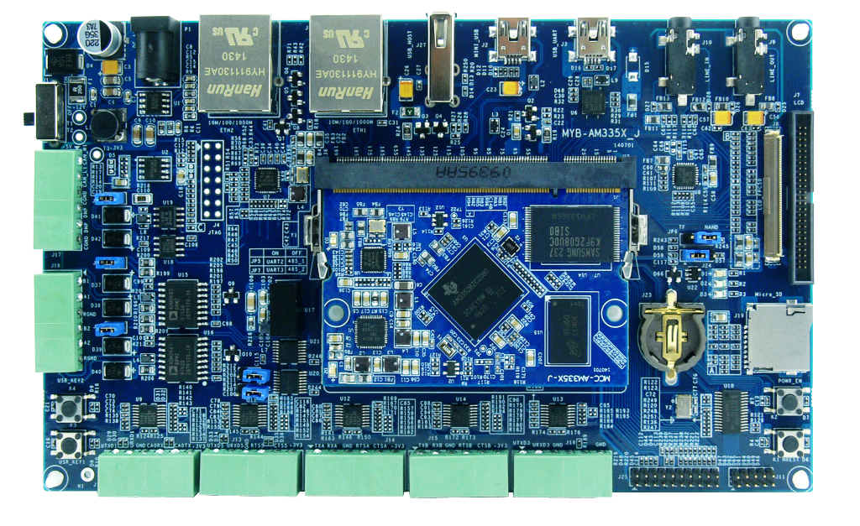

Figure ‑ MYD-JA5D4X

# Hardware Resource Introduction

## Core Board Resources Overview

MYC-JA5D4X integrates 512MB DDR2 SDRAM,512MB Nand Flash or 4GB eMMC，4MB Data Flash and 64KB EEPROM. In order to improve the stability of the system and to cope with possible system halted, MYC-JA5D4X integrates a power management chip. The core plate of MYC-JA5D4X load resources shown in Figure 2‑1:

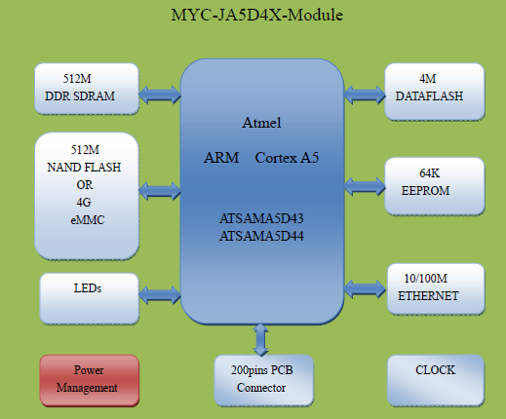

Figure ‑ Core Board Resources

## Bottom Hardware Resources

* A audio input interface (3.5mm)
* A dual-channel audio output interface (3.5mm)
* LCD touch screen interface(24-bit color)
* A HDMI output interface
* A ISI camera interfaces
* A 20 pin JTAG interface
* Two 10/100Mb/s Ethernet Interface
* Two high-speed USB Host
* A mini USB OTG
* Serials ports(include a debug serial port and an application serial port)
* A RS485 interface (with signal and power isolation)
* Two 20 PIN and A 30 PIN extended interface (include eight Secured I/Os, one SPI, one I2C,four UART etc.)
* A TF card interface
* Two User Indicator/System heartbeat Indicator
* Four keys(include one reset key, one user key, one WKUP key,one CS_BOOT key)

# Hardware Guide

## Plate Interface Specification

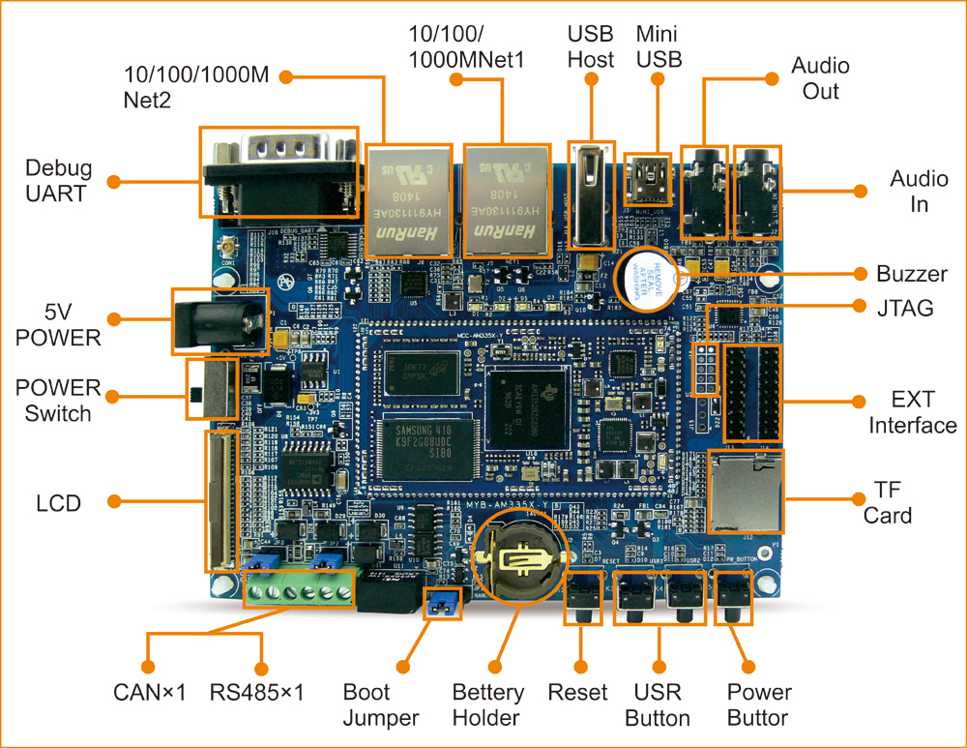

Figure ‑ MYD-JA5D4X Interface

### MYD-JA5D4X I/O Interface

| **No.** | **Interface** | **Remark** |
| --- | --- | --- |
| J1 | Core board interface | Install MYC-JA5D4X |
| J2 | Power input | 5V power socket, 2.1mm DC power seat |
| J4 | Battery holder | CR1225 |
| J5 | SD/MMC interface | Micro SD interface |
| J6 | RS485 interface | A RS485 interface |
| J7 | Debug serial port | UART3,DB9 |
| J8 | Application serial port | UART4,DB9 |
| J10 | Audio interface | Audio input 3.5mm |
| J12 | Audio output 3.5mm |
| J13 | HDMI interface | HDMI output |
| J14 | Ethernet Interface | RMII1,RJ45 |
| J15 | RMII0,RJ45 |
| J16 | JTAG interface | 20-PIN JTAG |
| J17 | USB Host | HSUSBB，HSUSBC USB Host |
| J18 | USB OTG | HSUSBA，Mini USB |
| J19 | Phone interface | Phone interface |
| J20 | LCD interface | 4.3 inch screen (7 inch screen will be supported later) |
| J21 | Extended interface | 20PIN,A TWI,A SPI,Two UART |
| J22 | Extended interface | 30PIN,GPIO |
| J23 | ISI interface | 30PIN ISI camera |
| J24 | Extended interface | 20PIN,Two UART,Eight Secured I/Os |
| D7(Bottom) | LED Indicator | LED Red |
| D9(Bottom) | LED Blue |
| D1(Core) | LED Blue |
| D2(Core) | LED Red |
| K1 | Button | Reset button, tact switch |
| K2 | WakeUp button, tact switch |
| K3 | User button, tact switch |
| K4 | Nand/Data Flash enable button, tact switch |

Table -

## Function Module Description

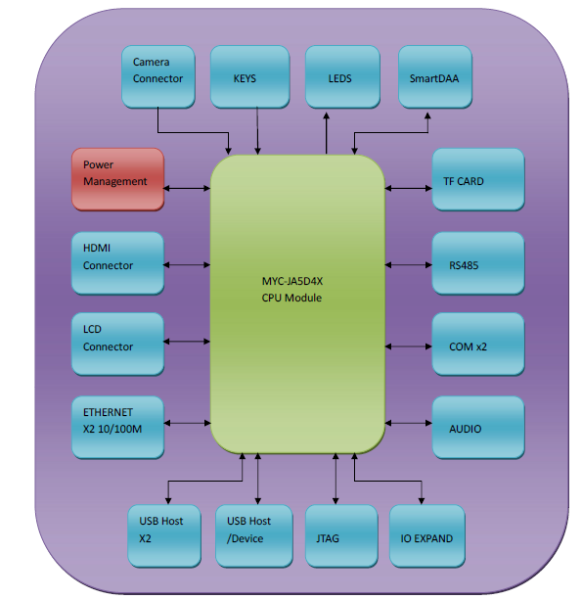

Figure ‑ Function Module

### Ethernet

MYD-JA5D4X integrates two Ethernet interface. As shown in Figure 3‑3, Ethernet interface 1 or Ethernet interface 2 are RMII interface, translate into physical layer signal by two PHY chips, and then connect to integrated block RJ45 output signals. Two PHY chips, one is integrated in the MYC-JA5D4X core board, another is located on MYB-JA5D4X floor.

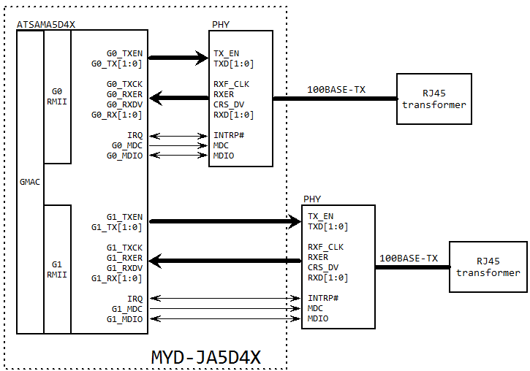

Figure ‑ Ethernet

### LCD Touch Screen

MYD-JA5D4X integrates 24 bit RGB LCD interface, supporting 480x272 resolution (4.3 inch screen) default, 800 x480 resolution (7 inch screen). You can choose MY-TFT043 (4.3 inch LCD) or MY-TFT070 (7.0 inch) module.

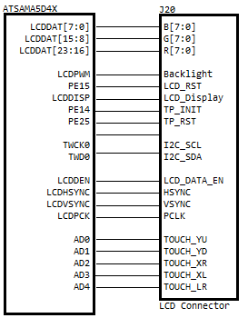

Figure ‑ LCD interface

### HDMI Interface

MYD-JA5D4X LCDDAT data convert HDMI signals through SIL9022A chip, its interface is shown in Figure 3‑5:

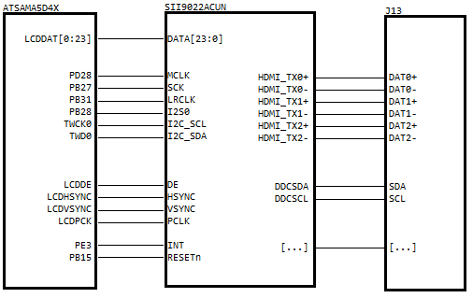

Figure ‑ HDMI Interface

### Audio CODEC

MYD-JA5D4X uses audio coding chip WM8904, TWI0 configuration interface, connected to ATSAMA5D4X SSC port, develop two 3.5mm Headset Jack J10 and J12, audio input and output.

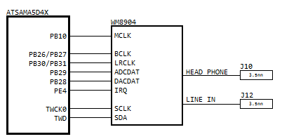

Figure ‑ Audio

### USB Interface

MYD-JA5D4X has three USB interfaces, USBA used Mini USB OTG, USBB and USBC Used for USB HOST.

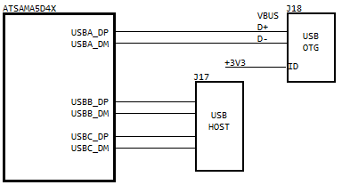

Figure ‑ USB

### USART Interface

MYD-JA5D4X has two serial ports via DB9 output, USART3 and USART4, USART4 extended out two serial through SN74CBTLV3257,one is converted RS485 function by ADM2483 chip,the other is serial port output by SP3232.USART3 as the debug serial port output by SP3232.

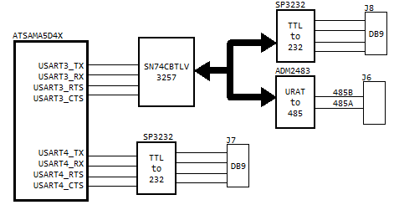

Figure ‑ USART

### ISI Interface

MYD-JA5D4X has one ISI output interfaces, connect backplane J23.

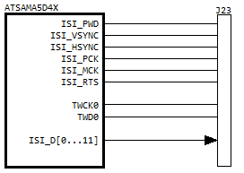

Figure ‑ ISI

### TF Card

MYD-JA5D4X TF Card connectes to MCI1 port of ATSAMA5D4X, connect backplane J5.

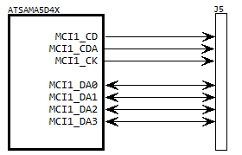

Figure ‑ TF Card

### JTAG Interface

MYD-JA5D4X has a 20PIN JTAG interface connected to J16。

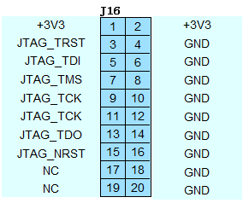

Figure ‑ JTAG

### Extended Interface

MYD-JA5D4X leads to the main interface to expand interface. J21/J22 and J24 interface.

⑴ J21

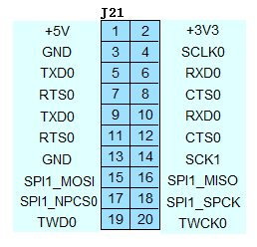

Figure ‑ J21

⑵ J22

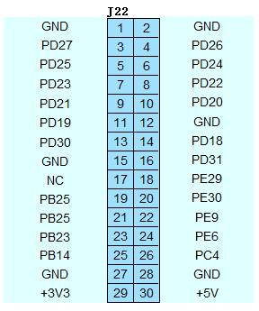

Figure ‑ J22

⑶ J24

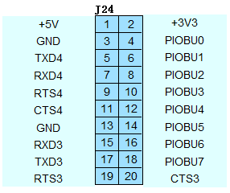

Figure ‑ J24

# Software Resources Instruction

## Linux Software Resources

Linux software resources shown in Table 4-1：

| **Category** | **Name** | **Description** | **source** |
| --- | --- | --- | --- |
| **Boot**  **loader** | U-boot | Secondary boot program, is responsible for system initialization and boot kernel  1. Support network to download images  2. Support settings, save the environment variable  3. Support memory content display, contrast, modify  4. Support bootcmd, bootargs | yes |
| **Kernel** | Linux 3.18 | Designed for MYD-JA5D4X hardware | yes |
| **Drivers** | USB Host | USB Host driver, support OHCI and EHCI | yes |
| USB Device | USB Device driver | yes |
| Ethernet | Ethernet driver | yes |
| MMC/SD | MMC/SD driver | yes |
| Nand Flash | Nand Flash driver | yes |
| I2C(TWI) | I2C driver | yes |
| SPI | SPI driver | yes |
| WDI | Watch Dog driver | YES |
| LCD Controller | LCD driver, for 4.3 inch, 7 inch | yes |
| RTC | RTC clock driver | yes |
| Touch Screen | 5-wire resistive touch screen driver | yes |
| PWM | PWM (Pulse Width Modulation) driver | yes |
| UART | Serial driver | yes |
| ADC | ADC driver | yes |
| LED | LED driver, GPIO LED and PWM LED | yes |
| GPIO | GPIO driver | yes |
| ISI | ISI Camera driver | yes |
| **Filesystem** | rootfs | Base on build root | Bin |
| rootfs-qt | Qt file system | Bin |
| **Applications** | Key&LED | Key&LED test program | yes |
| NET | TCP/IP Sokect C/S test program | yes |
| RTC | RTC clock testing experiment | yes |
| I2C(TWI) | i2c-dev application interface demo | yes |
| EEPROM | EEPROM Application interface demo | yes |
| RS485 | RS485 test program | yes |
| RS232 | RS232 test program | yes |
| Audio | Audio test program | yes |
| Framebuffer | Display demo | yes |

Table -

# Software Guide

## Download Firmware to Development Board

Development board has been recorded with program, refer to < *MYD-JA5D4X Linux Development Manual* > to operate.

## Start Development Board

Disconnect JP1 jumper cap, namely the NANDFlash boot mode.

Serial line is connected with host computer and J7 on development board, and open super terminal on the host.

LCD touch screen is connected to J20 on development board.

5V power supply facilities into power socket, switch on the power, and set J2 power switch to the ON position.

Super terminal will print out boot information from the development board, after development board start completion, You need to use the root user to log in command line terminal without password, and Qt demo program will run automatically, LCD will be displayed as shown in Figure 5‑1 interface.

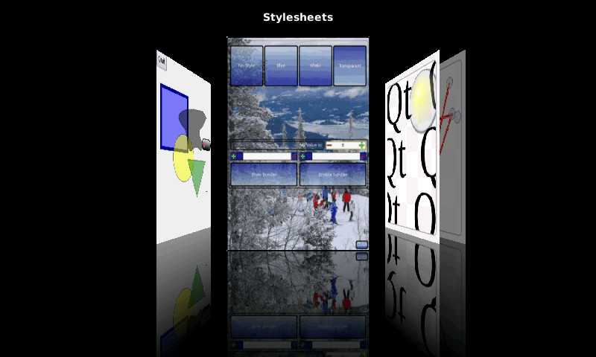

Figure ‑ Boot interface

# Machine Parameter

* Working Temperature:
* Industrial Grade：-40°C ~+85°C
* Commercial Grade: -20°C ~+70°C
* Relative humidity: 20%~90%, Non-condensing
* The ambient temperature：-50°C ~+100°C
* Power supply：
* Core board：3.3V/2A
* Cover plate：5V/2A power supply
* The power consumption of the system：
* Core board：NA
* Cover plate：NA
* The core board interface type：200PIN SO-DIMM
* PCB layer：
* Floor: 4 layer, the production tin spraying process, independent of the ground signal layer, lead-free
* The core board: 8 layers, gold production, independent grounding signal layer, lead-free
* Mechanical dimensions:
* Bottom: [153.92 x 109.73 x 1.6]mm
* Core board: [67.6 x 45 x 1.0] mm

MYD-JA5D4X board machine dimensions shown in Figure 6‑1:

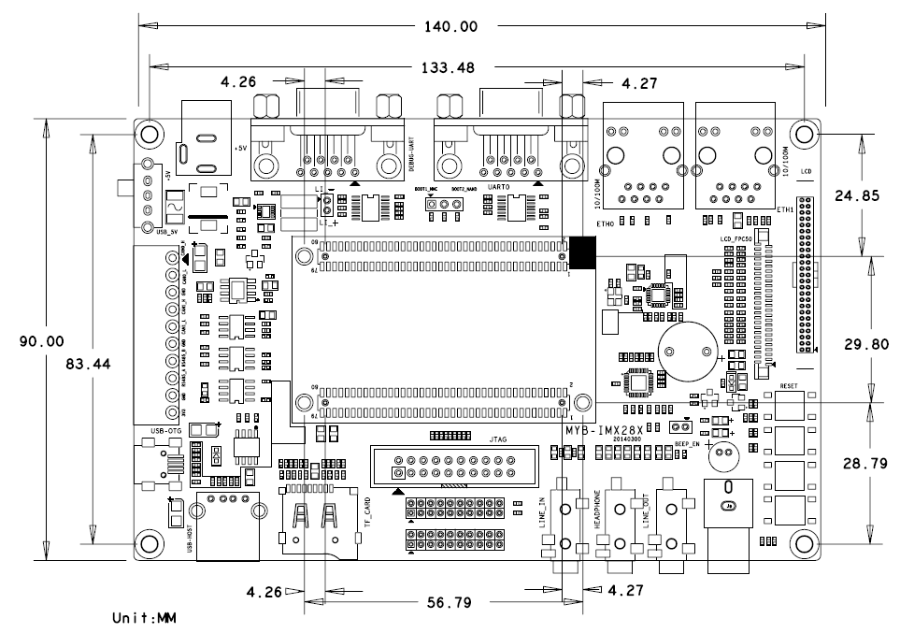

Figure ‑ Machine Dimensions

# Appendix 1 Warranty & Technical Support Services

**MYIR Tech Limited** is a global provider of ARM hardware and software tools, design solutions for embedded applications. We support our customers in a wide range of services to accelerate your time to market.

MYIR is an ARM Connected Community Member and work closely with ARM and many semiconductor vendors. We sell products ranging from board level products such as development boards, single board computers and CPU modules to help with your evaluation, prototype, and system integration or creating your own applications. Our products are used widely in industrial control, medical devices, consumer electronic, telecommunication systems, Human Machine Interface (HMI) and more other embedded applications. MYIR has an experienced team and provides custom design services based on ARM processors to help customers make your idea a reality.

The contents below introduce to customers the warranty and technical support services provided by MYIR as well as the matters needing attention in using MYIR’s products.

**Service Guarantee**

MYIR regards the product quality as the life of an enterprise. We strictly check and control the core board design, the procurement of components, production control, product testing, packaging, shipping and other aspects and strive to provide products with best quality to customers. We believe that only quality products and excellent services can ensure the long-term cooperation and mutual benefit.

**Price**

MYIR insists on providing customers with the most valuable products. We do not pursue excess profits which we think only for short-time cooperation. Instead, we hope to establish long-term cooperation and win-win business with customers. So we will offer reasonable prices in the hope of making the business greater with the customers together hand in hand.

**Delivery Time**

**MYIR will always keep a certain stock for its regular products. If your order quantity is less than the amount of inventory, the delivery time would be within three days; if your order quantity is greater than the number of inventory, the delivery time would be always four to six weeks. If for any urgent delivery, we can negotiate with customer and try to supply the goods in advance.**

**Technical Support**

**MYIR has a professional technical support team. Customer can contact us by email (**[support@myirtech.com](mailto:support@myirtech.com)**), we will try to reply you within 48 hours. For mass production and customized products, we will specify person to follow the case and ensure the smooth production.**

**After-sale Service**

**MYIR offers one year free technical support and after-sales maintenance service from the purchase date. The service covers:   
1. Technical support service**

1. MYIR offers technical support for the hardware and software materials which have provided to customers;
2. To help customers compile and run the source code we offer;
3. To help customers solve problems occurred during operations if users follow the user manual documents;
4. To judge whether the failure exists;
5. To provide free software upgrading service.

However, the following situations are not included in the scope of our free technical support service:

1. Hardware or software problems occurred during customers’ own development;
2. Problems occurred when customers compile or run the OS which is tailored by themselves;
3. Problems occurred during customers’ own applications development;
4. Problems occurred during the modification of MYIR’s software source code.

2. After-sales maintenance service

The products except LCD, which are not used properly, will take the twelve months free maintenance service since the purchase date. But following situations are not included in the scope of our free maintenance service:

1. The warranty period is expired;
2. The customer cannot provide proof-of-purchase or the product has no serial number;
3. The customer has not followed the instruction of the manual which has caused the damage the product;
4. Due to the natural disasters (unexpected matters), or natural attrition of the components, or unexpected matters leads the defects of appearance/function;
5. Due to the power supply, bump, leaking of the roof, pets, moist, impurities into the boards, all those reasons which have caused the damage of the products or defects of appearance;
6. Due to unauthorized weld or dismantle parts or repair the products which has caused the damage of the products or defects of appearance;
7. Due to unauthorized installation of the software, system or incorrect configuration or computer virus which has caused the damage of products.

Warm tips:

1. MYIR does not supply maintenance service to LCD. We suggest the customer first check the LCD when receiving the goods. In case the LCD cannot run or no display, customer should contact MYIR within 7 business days from the moment get the goods.
2. Please do not use finger nails or hard sharp object to touch the surface of the LCD.
3. MYIR suggests user purchasing a piece of special wiper to wipe the LCD after long time use, please avoid clean the surface with fingers or hands to leave fingerprint.
4. Do not clean the surface of the screen with chemicals.
5. Please read through the product user manual before you using MYIR’s products.
6. For any maintenance service, customers should communicate with MYIR to confirm the issue first. MYIR’s support team will judge the failure to see if the goods need to be returned for repair service, we will issue you RMA number for return maintenance service after confirmation.

3. Maintenance period and charges

a) MYIR will test the products within three days after receipt of the returned goods and inform customer the testing result. Then we will arrange shipment within one week for the repaired goods to the customer. For any special failure, we will negotiate with customers to confirm the maintenance period.

b) For products within warranty period and caused by quality problem, MYIR offers free maintenance service; for products within warranty period but out of free maintenance service scope, MYIR provides maintenance service but shall charge some basic material cost; for products out of warranty period, MYIR provides maintenance service but shall charge some basic material cost and handling fee.

4. Shipping cost

During the warranty period, the shipping cost which delivered to MYIR should be responsible by user; MYIR will pay for the return shipping cost to users when the product is repaired. If the warranty period is expired, all the shipping cost will be responsible by users.

5. Products Life Cycle

MYIR will always select mainstream chips for our design, thus to ensure at least ten years continuous supply; if meeting some main chip stopping production, we will inform customers in time and assist customers with products updating and upgrading.

**Value-added Services**

1. MYIR provides services of driver development base on MYIR’s products, like serial port, USB, Ethernet, LCD, etc.
2. MYIR provides the services of OS porting, BSP drivers’ development, API software development, etc.
3. MYIR provides other products supporting services like power adapter, LCD panel, etc.
4. ODM/OEM services.



**MYIR Tech Limited**

Room 1306, Wensheng Center, Wenjin Plaza,

North Wenjin Road, Luohu District, Shenzhen, China 518020

Support Email: [support@myirtech.com](mailto:support@myirtech.com)

Sales Email: [sales@myirtech.com](mailto:sales@myirtech.com)

Phone: +86-755-22984836

Fax: +86-755-25532724

Website: www.myirtech.com